**Lab 1: Introduction to Wireshark**

University of Windsor

Department of Electrical and Computer Engineering

ELEC 8560 – Computer Networks

Semester: Fall 2023

**Student Name**: Amey Mahendra Thakur

**Student number**: 110107589

**Answers:**

1. Wireshark displayed several protocols. The protocols that WireShark captured were following:

* TCP
* TLSv1.2
* TLSv1.3
* ARP
* MDNS
* SSL
* DNS
* SSDP
* HTTP

Process:

Step 1 - Start Wireshark

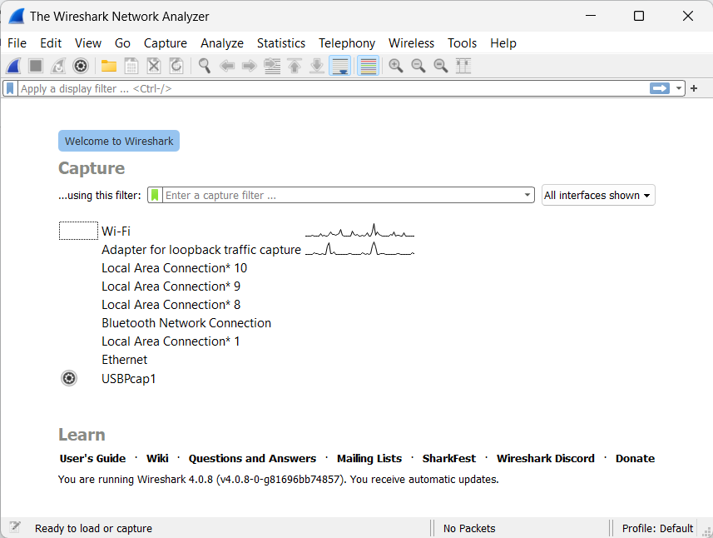

Step 2 - Open Wireshark and Select the Capture Interface:

In Wireshark, click on the interface you want to capture packets from (e.g., Wi-Fi).

Start the Capture:

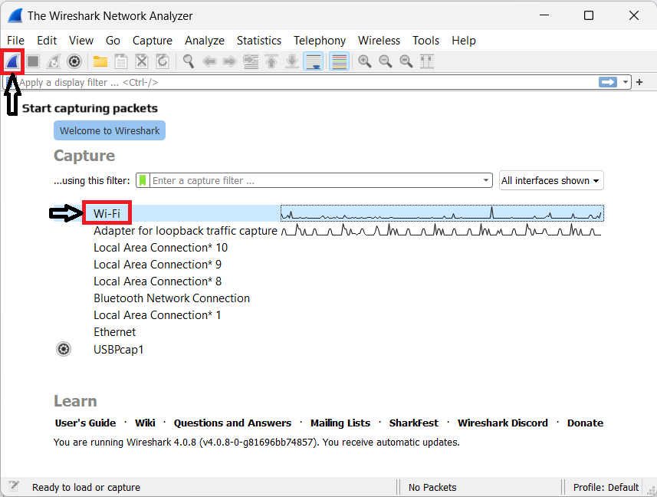

Step 3 - Now, open web browser and access the given URL

“<http://gaia.cs.umass.edu/wireshark-labs/INTRO-wireshark-file1.html>”

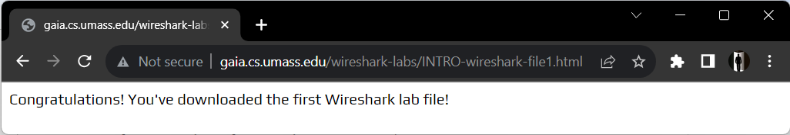

Step 4 - Return to Wireshark and stop the packet capture by clicking the "Stop" button.

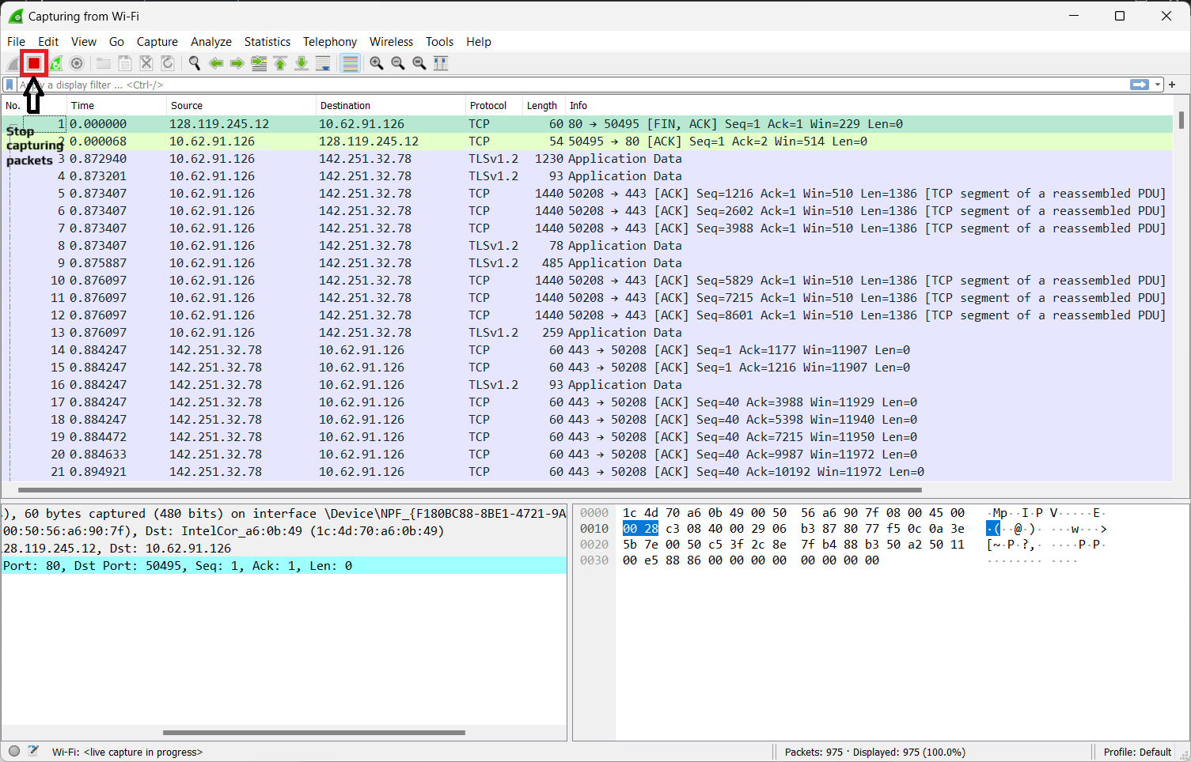

Step 5 - Look at the packets captured in Wireshark. Check the "Protocol" column in Wireshark to identify which protocols are present in the captured packets.

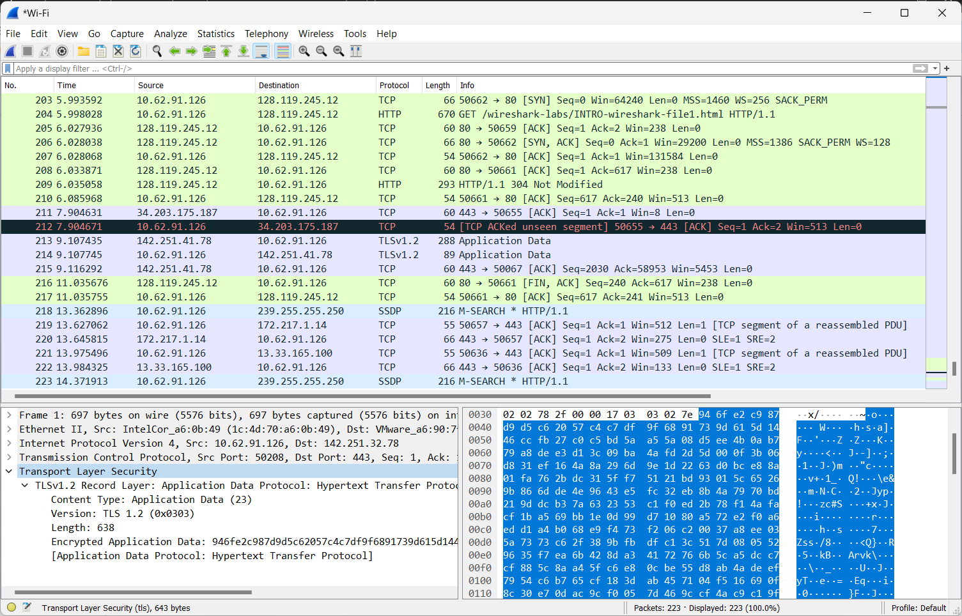

2. The time difference between HTTP GET and HTTP OK is 0.37059 seconds.

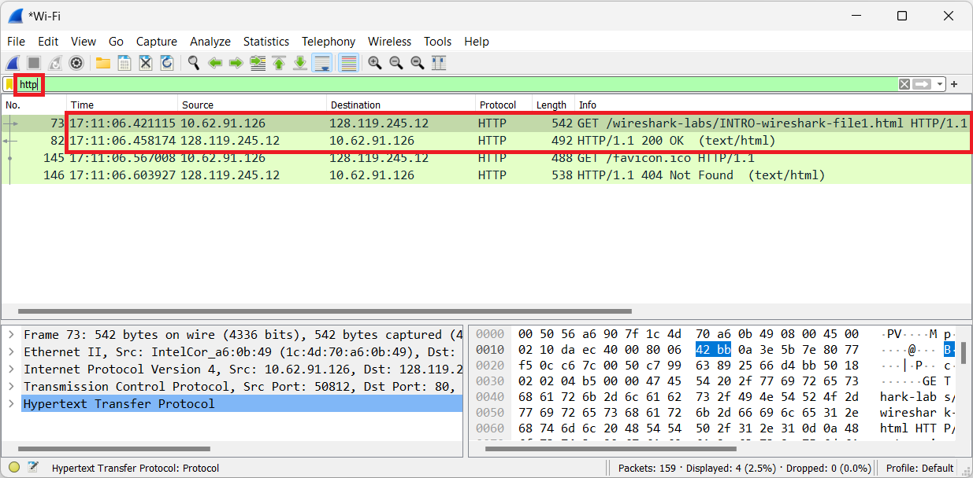

3.The Internet address of the gaia.cs.umass.edu (also known as www-net.cs.umass.edu) is **128.119.245.12**

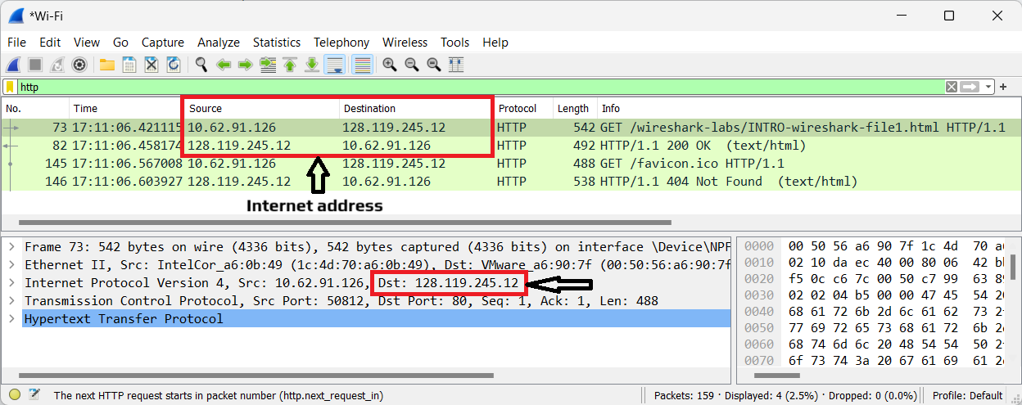

The Internet address of my computer (the computer that sent the HTTP GET message) is **10.62.91.126**

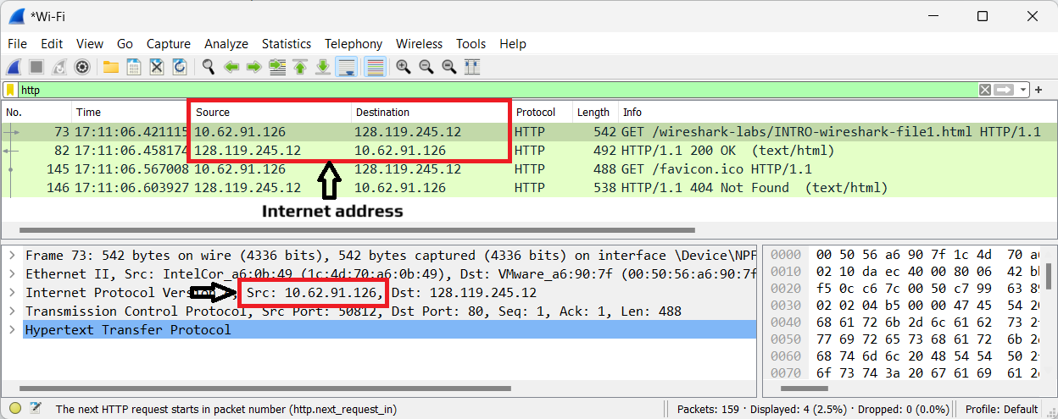

4. I used edge browser and it is shown in wireshark by the User-Agent attribute

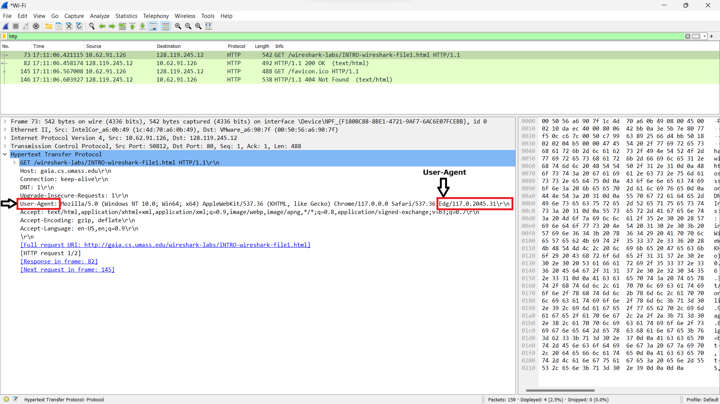

5. The destination port number is 80.

